
Accommodation

PARK HYATT TORONTO - Conference Venue
www.parktoronto.hyatt.com

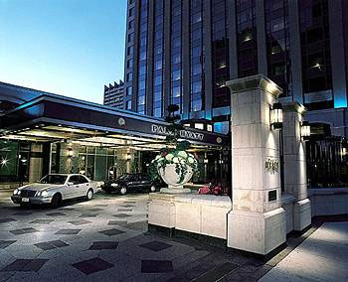

4 Avenue Road, Toronto, Ontario
To reserve call 1 800 233-1234 and ask for the exclusive University of Toronto rate

